CHAPTER FOUR

# RESULTS

Species Occurrence

Species belonging to 10 families were caught during the study. Since the family Anguillidae family was the target interest of study, 9 different families were caught as by-catch. Tank gobby (*Glossogobius giuris* Hamilton, 1822), dominated the catch with 947 individuals and had a mean total length 14 ±10SD cm with a mean weight of 23 grams. Sabaki tilapia (*Oreochromis spirulus spirulus* Gunther, 1894) had an abundance of 118 individuals with an average weight of 26 grams with a standard length and total length of 12 cm and 15 cm respectively. Anguillidae individuals from *A. bengalensis* species. *Anguilla bengalensis* had an average total length of 5.5 cm weighing 5 grams. Mozambique tilapia (*Oreochromis mossambicus* Peters,1852) had 47 individuals, then the snake eel had 45 individuals. Snake eels (*Pisonodophis boro* Hamilton 1822) were the longest, having a total length of 108 cm and weighing 71 grams. Table 1 illustrates the summary results of the caught species. The target species belonging to *Anguillidae* family were *A. bengalensis* which were most abundant with 50 individuals, followed *A. mossambica* with 23 individuals and *A.* *marmorata* with 2 individuals.

Table 1: Summary of species composition caught in the study area.

| Species | Morphometric Measurements | | | | |
| --- | --- | --- | --- | --- | --- |
| Abundance | Total length (cm) | Standard length (cm) | Depth (cm) | Weight (g) |
| ***Anguillidae*** | | | | | |
| *Anguilla mossambica* | 23.0 | 6.52 | 0 | 0 | 5.25 |
| *Anguilla bengalensis* | 51.0 | 5.55 | 0 | 0 | 5.15 |
| *Anguilla marmorata* | 2.0 | 5.00 | 0 | 0 | 5.10 |
| ***Gobiidae*** | | | | | |
| *Glossogobius giuris* | 946.9 | 14.55 | 10.01 | 5.35 | 23.26 |
| *Stenogobius kenyae* | 25.0 | 69.97 | 57.04 | 12.38 | 17.32 |
| ***Portunidae*** | | | | | |
| *Scylla serrata* | 41.0 | 10.50 | 5.10 | 9.0 | 21.30 |
| ***Penaeidae*** | | | | | |
| *Penaeus indicus* | 5.0 | 0 | 0 | 0 | 529.29 |
| *Ophichthidae* | | | | | |
| *Pisonodophis boro* | 45.0 | 108.70 | 0 | 8.72 | 71.35 |
| ***Sciaenidae*** | | | | | |
| *Otolithes ruber* | 14.0 | 20.22 | 16.76 | 7.95 | 21.69 |
| ***Mugilidae*** | | | | | |
| *Planiliza alata* | 24.0 | 4.263 | 4.97 | 0 | 2.67 |
| ***Bagridae*** | | | | | |
| *Bagrus docmak* | 1.0 | 16.60 | 13.00 | 0 | 38.00 |
| *Bagrus docmak* | 35.0 | 39.44 | 32.41 | 7.55 | 78.37 |
| ***Cichlidae*** | | | | | |
| *Oreochromis spirulus spirulus* | 118.0 | 15.36 | 12.49 | 4.79 | 26.64 |
| *Oreochromis mossambicus* | 47.0 | 16.33 | 11.79 | 4.62 | 15.88 |
| ***Cyprinidae*** | | | | | |
| *Barbus oxyrhynchus* | 1.0 | 124.0 | 97.0 | 32.0 | 19.0 |

## Occurrence of eels

A total of 76 juvenile anguillid eels were collected. The individual life stages observed to occur in the Sabaki Estuary were, glass eels, which appeared transparent in colour (Figure 6) and elvers which appeared pigmented (Figure 7). Glass eels were more abundant at 87% (n = 66) while elvers were less abundant at 13% (n = 10). Among the juvenile anguillid eels captured, *A. bengalensis* (Figure 8)was the most abundant (n = 50). This was followed by *A. mossambica* (Figure 9)*,* with 23 individuals while only 3 individuals of *A. marmorata* (Figure 10)*,* were captured as presented Most of the juvenile anguillid eels caught were glass eels (Table 4). Only *A. mossambica* and *A. bengalensis* species had elvers. *Anguilla bengalensis* were the most abundant with 52 individuals, with 50 being glass eels and 2 elvers. This was followed by *A. mossambica* with 22 individuals where, 15 were glass eels and 8 were elvers. Only two *A. marmorata* were caught during this study.

Table 2: Results showing life stages of juvenile anguillid eels captured in the Sabaki Estuary

| Species | Life Stage | | Total |
| --- | --- | --- | --- |
|  | Elver | Glass eel |  |
| Anguilla bengalensis | 2 | 48 | 50 |
| Anguilla mossambica | 8 | 14 | 22 |
| Anguilla marmorata | NA | 4 | 4 |
| Total | 10 (13%) | 66 (87%) | 76 |

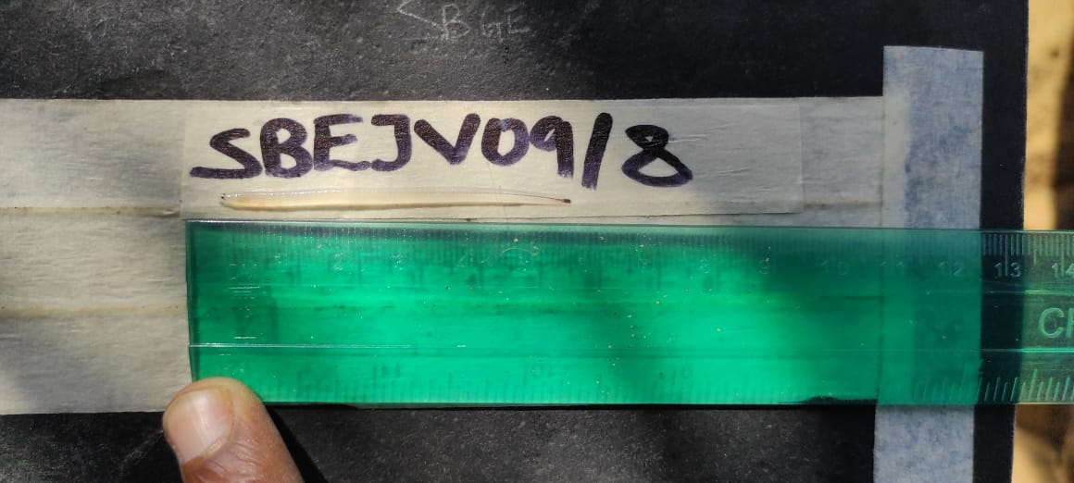

Figure 6: A photograph displaying the transparent colouration of a glass eel captured in the Sabaki Estuary, previously preserved in ethanol (Photo by Gitonga, 2021)

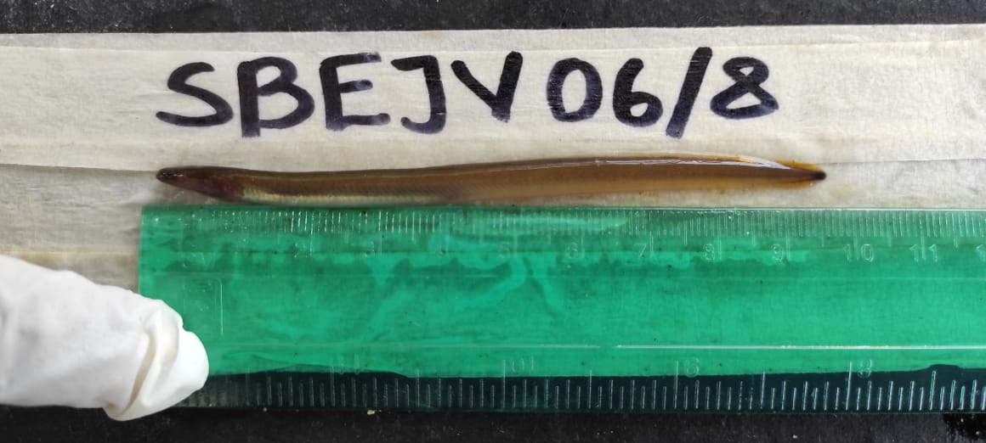

Figure 7: A photograph displaying an elver with pigmentation captured in Sabaki Estuary (Photo by Gitonga, 2021)

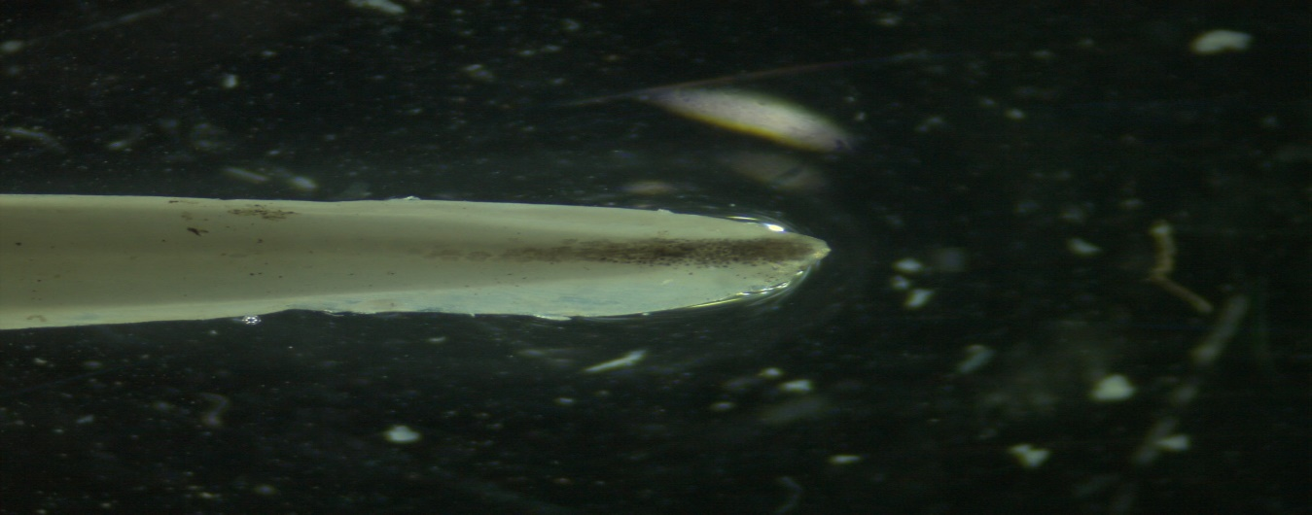

**SBEJV22/8 (*Anguilla bengalensis*)**

Figure 8: A photograph showing tail pigmentation of A. bengalensis glass eel taken by Stemi 305, Carl Zeis microscope GmbH, Germany using ZEN imaging software at x 2 magnification.

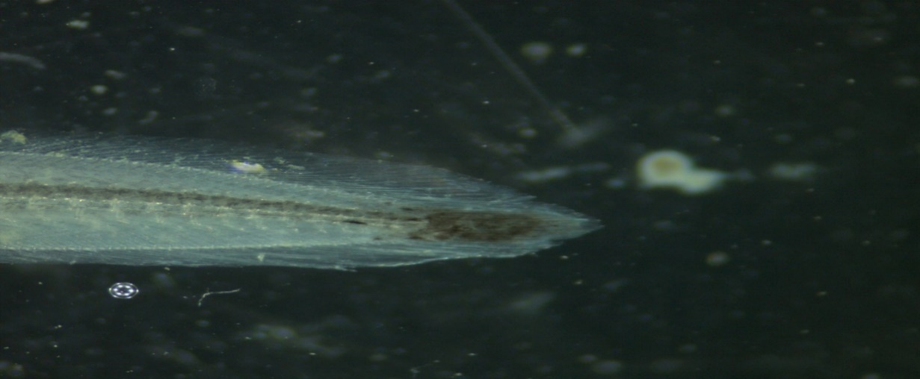

**SBEJV05/8 (*Anguilla mossambica*)**

Figure 9: A photograph showing tail pigmentation of A. mossambica glass eel taken by Stemi 305, Carl Zeis microscope GmbH, Germany using ZEN imaging software at x 2 magnification.

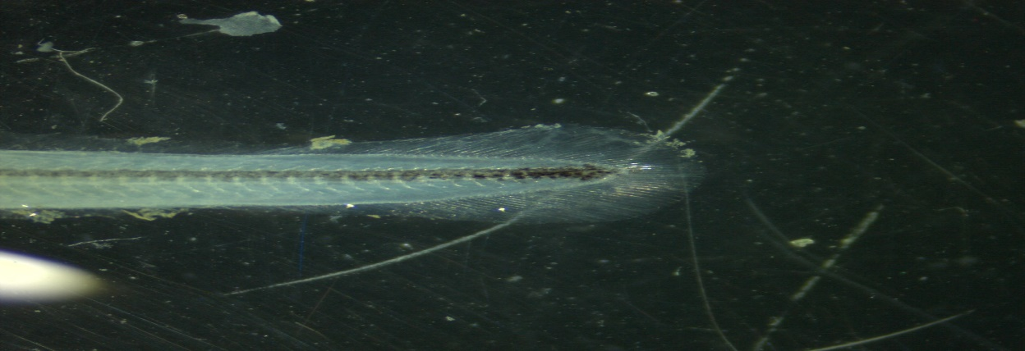

**SBEJV04/8 (*Anguilla marmorata*)**

Figure 10: A photograph showing tail pigmentation of A. marmorata glass eel taken by Stemi 305, Carl Zeis microscope GmbH, Germany using ZEN imaging software at x 2 magnification.

**Catch per unit of effort for anguillids.**

Every site had a single net fitted in one data and removed after fours every month. Therefore, the effort was constant. As illustrated in the table below the catch per unit effort was 12 individuals per net per day for glass eels of *A. bengalensis* and 4 glass eels of *A. mossambica* per net per day. Among the elvers of *A. mossambica,* only two individuals were caught per day per net. Approximately only 1 individual was caught per day per net among the elvers of *A. bengalensis* and glass eels of *A. marmorata.*

| Species | Stage | Number | CPUE |
| --- | --- | --- | --- |
| *A. bengalensis* | Glass eel | 50 | 12.5 |
| *A. mossambica* | Glass eel | 14 | 3.5 |
| *A. mossambica* | Elver | 8 | 2 |
| *A. bengalensis* | Elver | 2 | 0.5 |
| *A. marmorata* | Glass eel | 2 | 0.5 |

## Juvenile anguillid eels morphometrics

Morphometric results showed that, *A. mossambica* was the largest anguillid with 63 ± 18 SD mm followed by *A. bengalensis* at 54 ± 5 SD mm while *A. marmorata* was the smallest of the three anguillids with 51 ± 4SD mm (Table 5). One-way analysis of variance (ANOVA) showed that the mean differences in total lengths among the three anguillid species were not statistically significant (ANOVA, p = 0.1). Fin morphometrics showed that, *A. mossambica* had the largest DF to AF length with 249 ± 282SD mm followed by *A. bengalensis* with 124 ± 43SD mm while *A. marmorata* had the shortest DF to AF length with 112 ± 25SD mm. The mean differences in DF to AF lengths were statistically significant among the three anguillid species as attested by the ANOVA results (ANOVA, p = 0.008). Results of FDI which were the lengtsh between dorsal and dorsal fin relative to the total length (LT) did not conform to Ege, (1939) taxonomic key. FDI for all for all 76 specimens were < 1% (Appendix 4).

Both eye and fin morphometric measurements showed a similar trend with *A. mossambica* having the largest morphometric measurements followed by *A. marmorata* and trailed by *A. bengalensis* though they were not statistically significant.

Table 5: Morphometrics of juvenile anguillids occurring in the Sabaki Estuary

| **Morphometrics (mm)** | **Anguilla bengalensis** | **Anguilla marmorata** | **Anguilla mossambica** | **P-VALUE (Anova)** |
| --- | --- | --- | --- | --- |
| Total length | 54 ± 5 | 51 ± 4 | 63 ± 18 | 0.10 |
| DF TO AF | 124 ± 43 | 112 ± 25 | 249 ± 282 | 0.015 |
| DA | 107 ± 45 | 91 ± 24 | 215 ± 270 | 0.026 |
| DG | 17.9 ± 6.3 | 19.3 ± 1.5 | 19.7 ± 6.3 | 0.2 |
| LH | 63 ± 8 | 65 ± 6 | 82 ± 73 | 0.5 |
| LV | 60 ± 10 | 61 ± 5 | 80 ± 75 | 0.9 |
| RH | 60 ± 9 | 60 ± 5 | 80 ± 73 | 0.5 |
| RV | 60 ± 9 | 62 ± 10 | 82 ± 75 | 0.4 |

**FACTOR INFLUENCING RECRUITMENT EELS**

**Seasonal Patterns**

Most anguillids were caught during the wet season (53) against 23 caught in the dry season. The Anguilla marmorata were only caught during the wet season. There was an association between anguillid species occurrence and seasons (p = 0.032) tested by a chi-square test of association.

| season | Anguilla bengalensis | Anguilla marmorata | Anguilla mossambica | Total | p-value |
| --- | --- | --- | --- | --- | --- |
| Dry | 20 (87%) | 0 (0%) | 3 (13%) | 23 (100%) | 0.032 |
| Wet | 30 (57%) | 4 (7.5%) | 19 (36%) | 53 (100%) |  |
| Total | 50 (66%) | 4 (5.3%) | 22 (29%) | 76 (100%) |  |

Elvers of A. bengalensis (n=2) and A. mossambica (n=8) were more abundant during the wet season. Anguilla marmorata had the least abundance of elvers (n=0) and glass eels (4) in both seasons. Occurrence of glass eels caught were more abundant, during the wet season (n=42) as compared to the dry season (n=23).

| season | Anguilla bengalensis | | Anguilla mossambica | | Anguilla Marmorata | | Total | |
| --- | --- | --- | --- | --- | --- | --- | --- | --- |
|  | Elvers | Glass eels | Elvers | Glass eels | Elvers | Glass eels | Elvers | Glass eels |
| Wet | 2 (20%) | 28 (65%) | 8 (80%) | 11 (26%) | 0 | 4 (9.3%) | 10 (100%) | 42 (100%) |
| Dry | 0 | 20 (87%) | 0 | 3 (13%) | 0 | 0 | 0 (100) | 23 (100%) |
| Total | 2 (20%) | 48 (73%) | 8 (80%) | 14 (21%) | 0 | 4 (6.1%) | 10 (100%) | 65 (100%) |

**Temporal Patterns**

**Moon Phases**

Anguilla bengalensis had higher abundance during the first quarter (n=8) and full moon (n=10) phases respectively. Anguilla marmorata showed low abundance (n=4) overall. Anguilla mossambica, exhibited the highest abundance during the first (n=4) and last quarter (n=4) lunar phases. The chi-sqaure statistical significance of the association between the moon phases and the catch rate showed no significant association between the two variables (P<0.2).

| Phases of Moon | Anguilla bengalensis | Anguilla marmorata | Anguilla mossambica | Total | p-value |
| --- | --- | --- | --- | --- | --- |
| First Quarter | 8 (57%) | 2 (14%) | 4 (29%) | 14 (100%) | 0.2 |
| Full moon | 10 (100%) | 0 (0%) | 0 (0%) | 10 (100%) |  |
| Last Quarter | 8 (67%) | 0 (0%) | 4 (33%) | 12 (100%) |  |
| Wanning Gibbous | 18 (64%) | 1 (3.6%) | 9 (32%) | 28 (100%) |  |
| Waxing Crescent | 6 (50%) | 1 (8.3%) | 5 (42%) | 12 (100%) |  |
| Total | 50 (66%) | 4 (5.3%) | 22 (29%) | 76 (100%) |  |

Most glass eels and elvers were caught during the Waning Gibbous (n=28), First Quarter (n=14), and Waxing Crescent (n=12) phases of the moon than during the Full Moon phase (n=10). Highest abundance of elvers occurred during the Last Quarter (n=3) and Waning Gibbous (n=6). In the Last Quarter phase, fewer glass eels and elvers were caught, except for A. mossambica, which had the highest abundance of elvers (n=11). Highest abundance of glass eels occurred during the Wanning gibbous (n=22) while Last quarter phase (n=9) had the least glass eel abundance.

| Phases of Moon | Anguilla bengalensis | | Anguilla marmorata | | Anguilla mossambica | | Total | |
| --- | --- | --- | --- | --- | --- | --- | --- | --- |
|  | Glass eels | Elvers | Glass eels | Elvers | Glass eels | Elvers | Glass eels | Elvers |
| First Quarter | 8 (57%) | 0 | 2 (14%) | 0 | 4 (29%) | 0 | 14 (100%) | 0 |
| Full moon | 10 (100%) | 0 | 0 (0%) | 0 | 0 (0%) | 0 | 10 (100%) | 0 |
| Last Quarter | 8 (89%) | 0 (0%) | 0 (0%) | 0 | 1 (11%) | 3 (100%) | 9 (100%) | 3 (100%) |
| Wanning Gibbous | 16 (73%) | 2 (33%) | 1 (4.5%) | 0 | 5 (23%) | 4 (67%) | 22 (100%) | 6 (100%) |
| Waxing Crescent | 6 (55%) | 0 (0%) | 1 (9.1%) | 0 | 4 (36%) | 1 (100%) | 11 (100%) | 1 (100%) |
| Total | 48 (73%) | 2 (20%) | 4 (6.1%) | 0 | 14 (21%) | 8 (80%) | 66 (100%) | 10 (100%) |

Anguilla bengalensis had the highest abundance among all three species, with the greatest catch occurring in October (n=10) and the least catch occurring in July (n=1) and September (n=1). In contrast, Anguilla marmorata had the lowest overall catch with (n=4) individuals captured in August. Anguilla mossambica presented a moderate catch rate, with the highest abundance occurring during August (n=18).

| Sampling Month | Anguilla bengalensis | Anguilla marmorata | Anguilla mossambica | Total | p-value |
| --- | --- | --- | --- | --- | --- |
| July | 1 (50%) | 0 (0%) | 1 (50%) | 2 (100%) | 0.2 |
| August | 29 (57%) | 4 (7.8%) | 18 (35%) | 51 (100%) |  |
| September | 1 (50%) | 0 (0%) | 1 (50%) | 2 (100%) |  |
| October | 10 (100%) | 0 (0%) | 0 (0%) | 10 (100%) |  |
| November | 9 (82%) | 0 (0%) | 2 (18%) | 11 (100%) |  |
| Total | 50 (66%) | 4 (5.3%) | 22 (29%) | 76 (100%) |  |

**Monthly Patterns**

The highest abundance of glass eels and elvers occurred in August (n=41), with Anguilla bengalensis being the most abundant species caught during this month. Anguilla mossambica (n=1) and A. bengalensis (n=1) showed similar occurrence for both glass eels and elvers observed in July, September, and November. October had the highest abundance of A. bengalensis of glass eels (n=10). Anguilla marmorata exhibited the lowest abundance for both glass eels and elvers, with only (n=4) individuals caught in August.

| Sampling Month | Anguilla bengalensis | | Anguilla marmorata | | Anguilla mossambica | | Total | |
| --- | --- | --- | --- | --- | --- | --- | --- | --- |
|  | Glass eels | Elvers | Glass eels | Elvers | Glass eels | Elvers | Glass eels | Elvers |
| July | 1 (50%) | 0 (0%) | 0 (0%) | 0 (0%) | 1 (50%) | 0 (0%) | 2 (100%) | 0 (0%) |
| August | 27 (66%) | 2 (20%) | 4 (9.8%) | 0 (0%) | 10 (24%) | 8 (80%) | 41 (100%) | 10 (100%) |
| September | 1 (50%) | 0 (0%) | 0 (0%) | 0 (0%) | 1 (50%) | 0 (0%) | 2 (100%) | 0 (0%) |
| October | 10 (100%) | 0 (0%) | 0 (0%) | 0 (0%) | 0 (0%) | 0 (0%) | 10 (100%) | 0 (0%) |
| November | 9 (82%) | 0 (0%) | 0 (0%) | 0 (0%) | 2 (18%) | 0 (0%) | 11 (100%) | 0 (0%) |
| Total | 48 (73%) | 2 (20%) | 4 (6.1%) | 0 (0%) | 14 (21%) | 8 (80%) | 66 (100%) | 10 (100%) |

Biotopes

| Biotope | Anguilla bengalensis | Anguilla marmorata | Anguilla mossambica | Total | p-value |
| --- | --- | --- | --- | --- | --- |
| Rocky/Muddy | 5 (50%) | 0 (0%) | 5 (50%) | 10 (100%) | 0.3 |
| Vegetation edges | 45 (68%) | 4 (6.1%) | 17 (26%) | 66 (100%) |  |
| Total | 50 (66%) | 4 (5.3%) | 22 (29%) | 76 (100%) |  |

Life stages of eels across biotopes

| Biotope | Anguilla bengalensis | | Anguilla marmorata | | Anguilla mossambica | | Total |  |
| --- | --- | --- | --- | --- | --- | --- | --- | --- |
|  | Glass eels | Elvers | Glass eels | Elvers | Glass eels | Elvers | Glass eels | Elvers |
| Rocky/Muddy | 4 (57%) | 1 (33%) | 0 (0%) | 0 (0%) | 3 (43%) | 2 (67%) | 7 (100%) | 3 (100%) |
| Vegetation edges | 44 (75%) | 1 (14%) | 4 (6.8%) | 0 (0%) | 11 (19%) | 6 (86%) | 59 (100%) | 7 (100%) |
| Total | 48 (73%) | 2 (20%) | 4 (6.1%) | 0 (0%) | 14 (21%) | 8 (80%) | 66 (100%) | 10 (100%) |